LAB 4 IICT

Rameezhassanraja268@gmai.com

Date:4/10/2023

All About Anime

NUML-F23-50489

**All about Anime**

|  |  |  |
| --- | --- | --- |
| **Anime Name** | **IMDB’s Ratings** | **Director** |
| One Piece | 8.9/10 | Eiichiro Oda. |
| Naruto | 8.4/10 | Masashi Kishimoto |
| Bleach | 8.2/10 | Noriaki Kubo |
| Baki Son of Oger | 6.8/10 | Keisuke Itagak |
| Hajime no Ippo  One Punch Man | 8.8/10  9.4/10 | George Morikawa.  Chikara Sakurai |

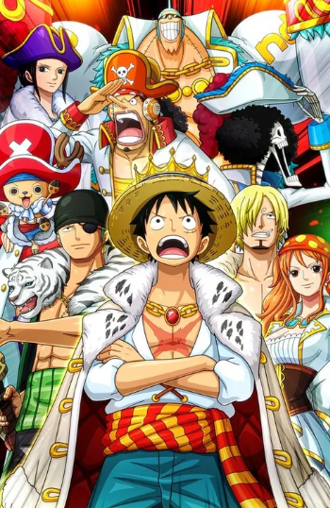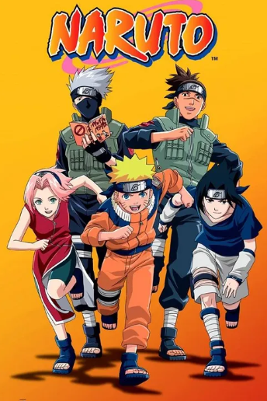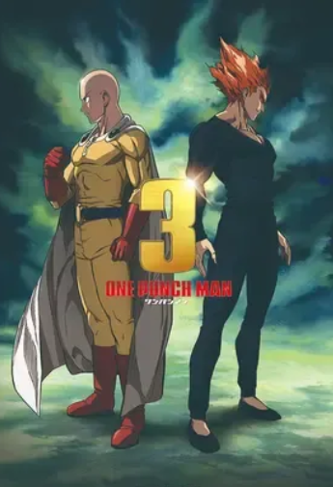

 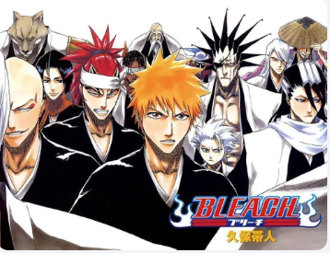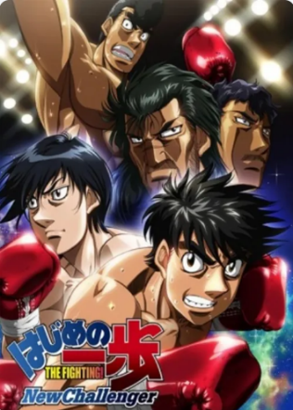

From Wikipedia.

Anime (Japanese: アニメ, IPA: [aꜜɲime] ) is hand-drawn and computer-generated animation originating from Japan. Outside Japan and in English, anime refers

[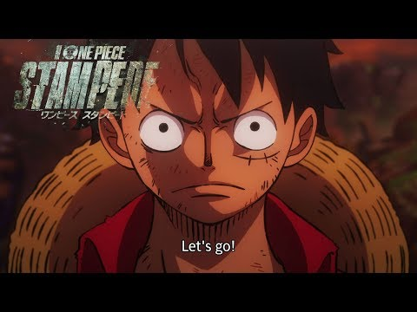](https://www.youtube.com/watch?v=S8_YwFLCh4U)[](https://www.youtube.com/watch?v=-G9BqkgZXRA)

[](https://www.youtube.com/watch?v=XnWKHvYCeKk)[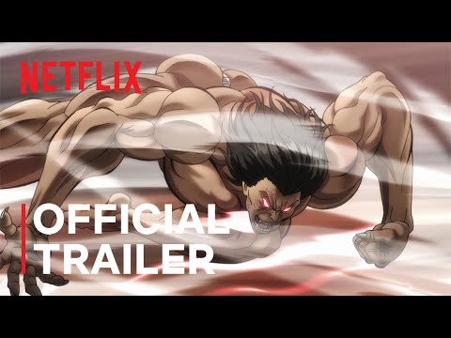](https://www.youtube.com/watch?v=ldUNk8mJzig)

One Piece:

<https://aniwatch.to/one-piece-100>

Naruto:

<https://aniwatch.to/naruto-shippuden-355>

Bleach:

<https://aniwatch.to/bleach-thousandyear-blood-war-the-separation-18420?ref=search>

Baki:

<https://aniwatch.to/hanma-baki-son-of-ogre-2nd-season-18458>